THE RAP NET: A GEODETIC POSITIONING NETWORK FOR ANDALUSIA (SOUTH SPAIN)

Hermosilla, A.⁽¹⁾ ; Torrecillas, C.⁽²⁾; Redondo, M.⁽¹⁾ ; Berrocoso, M.⁽³⁾ ; Paez, R.⁽³⁾ ;
Sanchez-Alzola, A.⁽³⁾
- Instituto de Cartografía de Andalucia ICA (SPAIN) aurora.hermosilla@juntadeandalucia.es; miguel.redondot@juntadeandalucia.es
- Departamento de Ingeniería Grafica, University of Seville (SPAIN) torrecillas@us.es
- Laboratorio de Astronomia, Geodesia y Cartografia, University of Cadiz (SPAIN) manuel.berrocoso@uca.es; raul.paez@uca.es; alberto.sanchez@uca.es

Abstract.
In this paper we present a description of the Andalusian Positioning Network, RAP: its objectives; design; development; its problems and its present status.
This geodetic network consists of 22 permanent GPS stations whose surveying will provide the data required to obtain relative positions of any place in Andalusia after applying some post-processing techniques and real-time differential corrections. Thus, high-precision geodetic coordinates referred to the WGS-84 system will be provided for anywhere in Andalusia. The station in the network can broadcast a differential correction via internet. Nine stations can also broadcast the RTK corrections via radio. The network has been designed to cover Andalusia and to provide real-time differential corrections in the whole area. The RAP network is referred to the EUREF system and is the new reference frame in Andalusia for the Institute of Cartography of Andalusia’s new cartography. It will also be used to settle photogrametric points or marks for the georeferencing of satellite images; to establish control points for reference networks in civil engineering or GIS applications; for numerous scientific and technological applications, such as precise geoid determination and tropospheric, ionospheric, and climatological studies, among others. Its millimetric precision will ensure success when integrating new projects with other cartographies.

1. Design and development of the rap network.
Through the Andalusian Cartographic Institute, the Andalusian Regional Government’s Ministry of Public Works and Transport is setting up a geodetic positioning network known as the Andalusian Positioning Network (RAP). Its objectives are:
- To constitute the new geodetic reference frame for Andalusia in ETRS89.
- To be of use in geodetic and topographical projects.
- To provide GPS data for post-processing.
- To broadcast differential corrections (code and carrier) via internet and radio.

The stations’ locations have been selected according to a spatial analysis made using ESRI ArcGIS 9.0 software where criteria such as homogenous geometric distribution, the highest coverage of the population and the greatest coastal cover have been imposed. Also considered was the availability of 22 sets of equipment, 9 of them having more features than the other 13. The Astronomy, Geodesy and Cartography Laboratory (LAGC) of the University of Cadiz (UCA) was charged with the network’s design, development, quality control and geodetic maintenance. The premises of its spatial design were:
  - Distance < 70 km between GPS stations.
  - Almost one station in each Andalusian provincial capital (8 capitals).
  - One station near the Straits of Gibraltar.
  - Hospitals were considered to be good locations because of their emergency electricity supply and the fact that they function 24/7.
  - Public Education centres, Public buildings or Natural Parks being other possibilities.

Figure 1 illustrates final distribution that mostly satisfied the imposed determinants. In the final design the stations have a separation of between 50 and 70 km. from each other. This ensures the differential corrections service throughout 100% of the territory, either directly or via radio or internet. The final number of stations was 22 in order to solve the positioning problem in Andalusia, including the coastal strip.
The RAP network was designed in two different stages, deciding the differences with regard to the stations’ equipment and location. The first-stage stations, located in the eight Andalusian capitals and in Algeciras, have more equipment. In contrast, the second-stage stations, located in more sparsely populated areas, have less equipment – even when they keep geodesic characteristics.
At present 19 out the 22 stations have already been completed, including all those from the first stage which are fully operational. Also working are ROND (Ronda), CAAL (Calar Alto) and OSUN (Osuna) while the rest of the stations built are pending connection to the Control Centre.

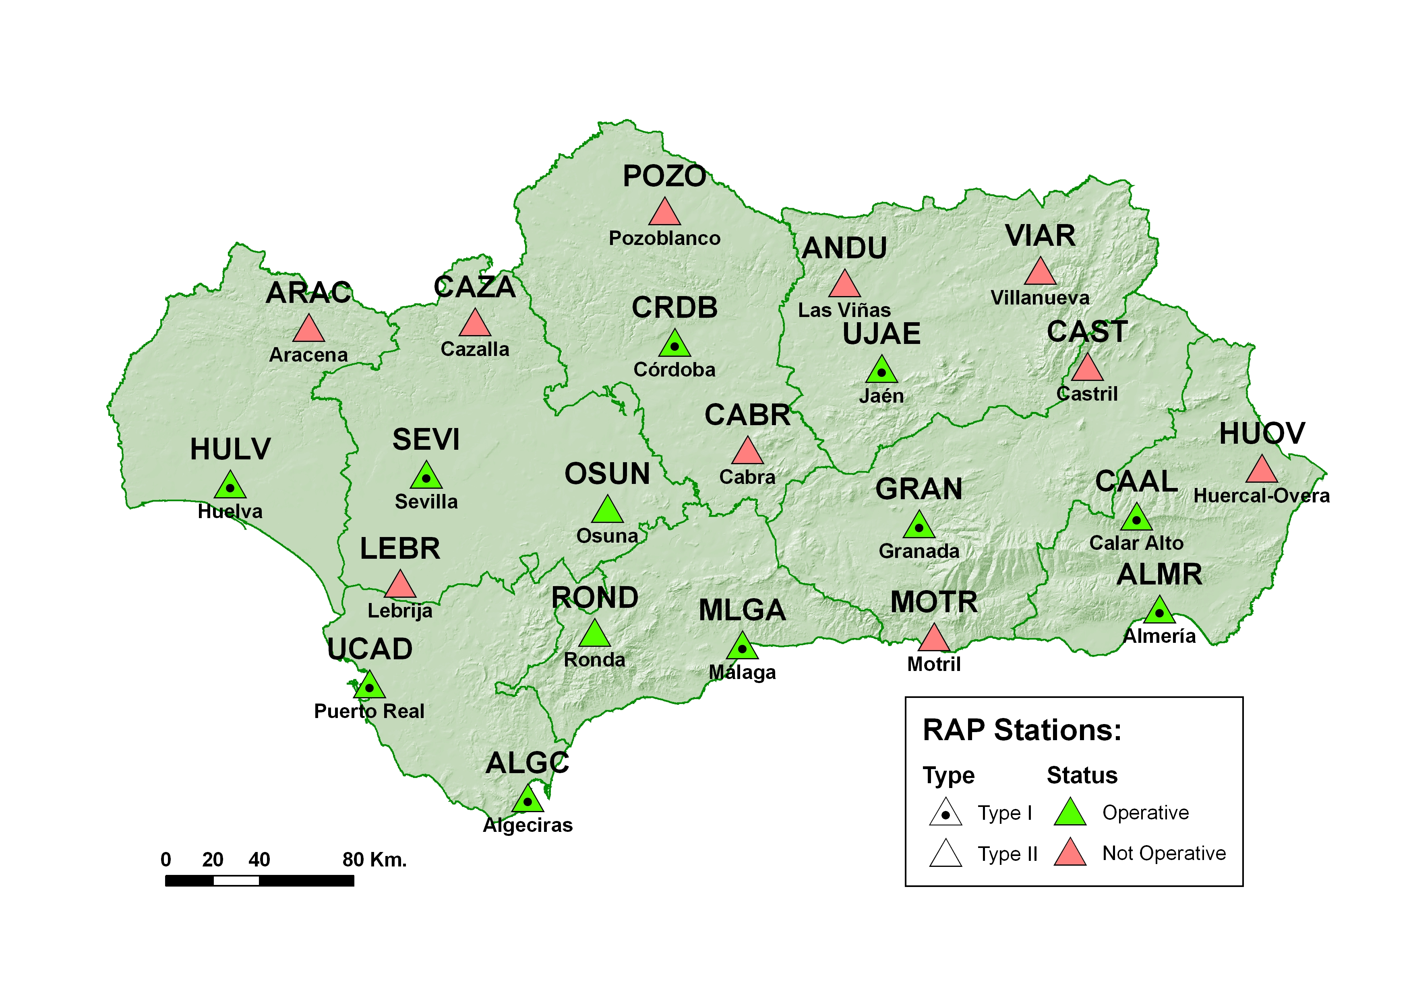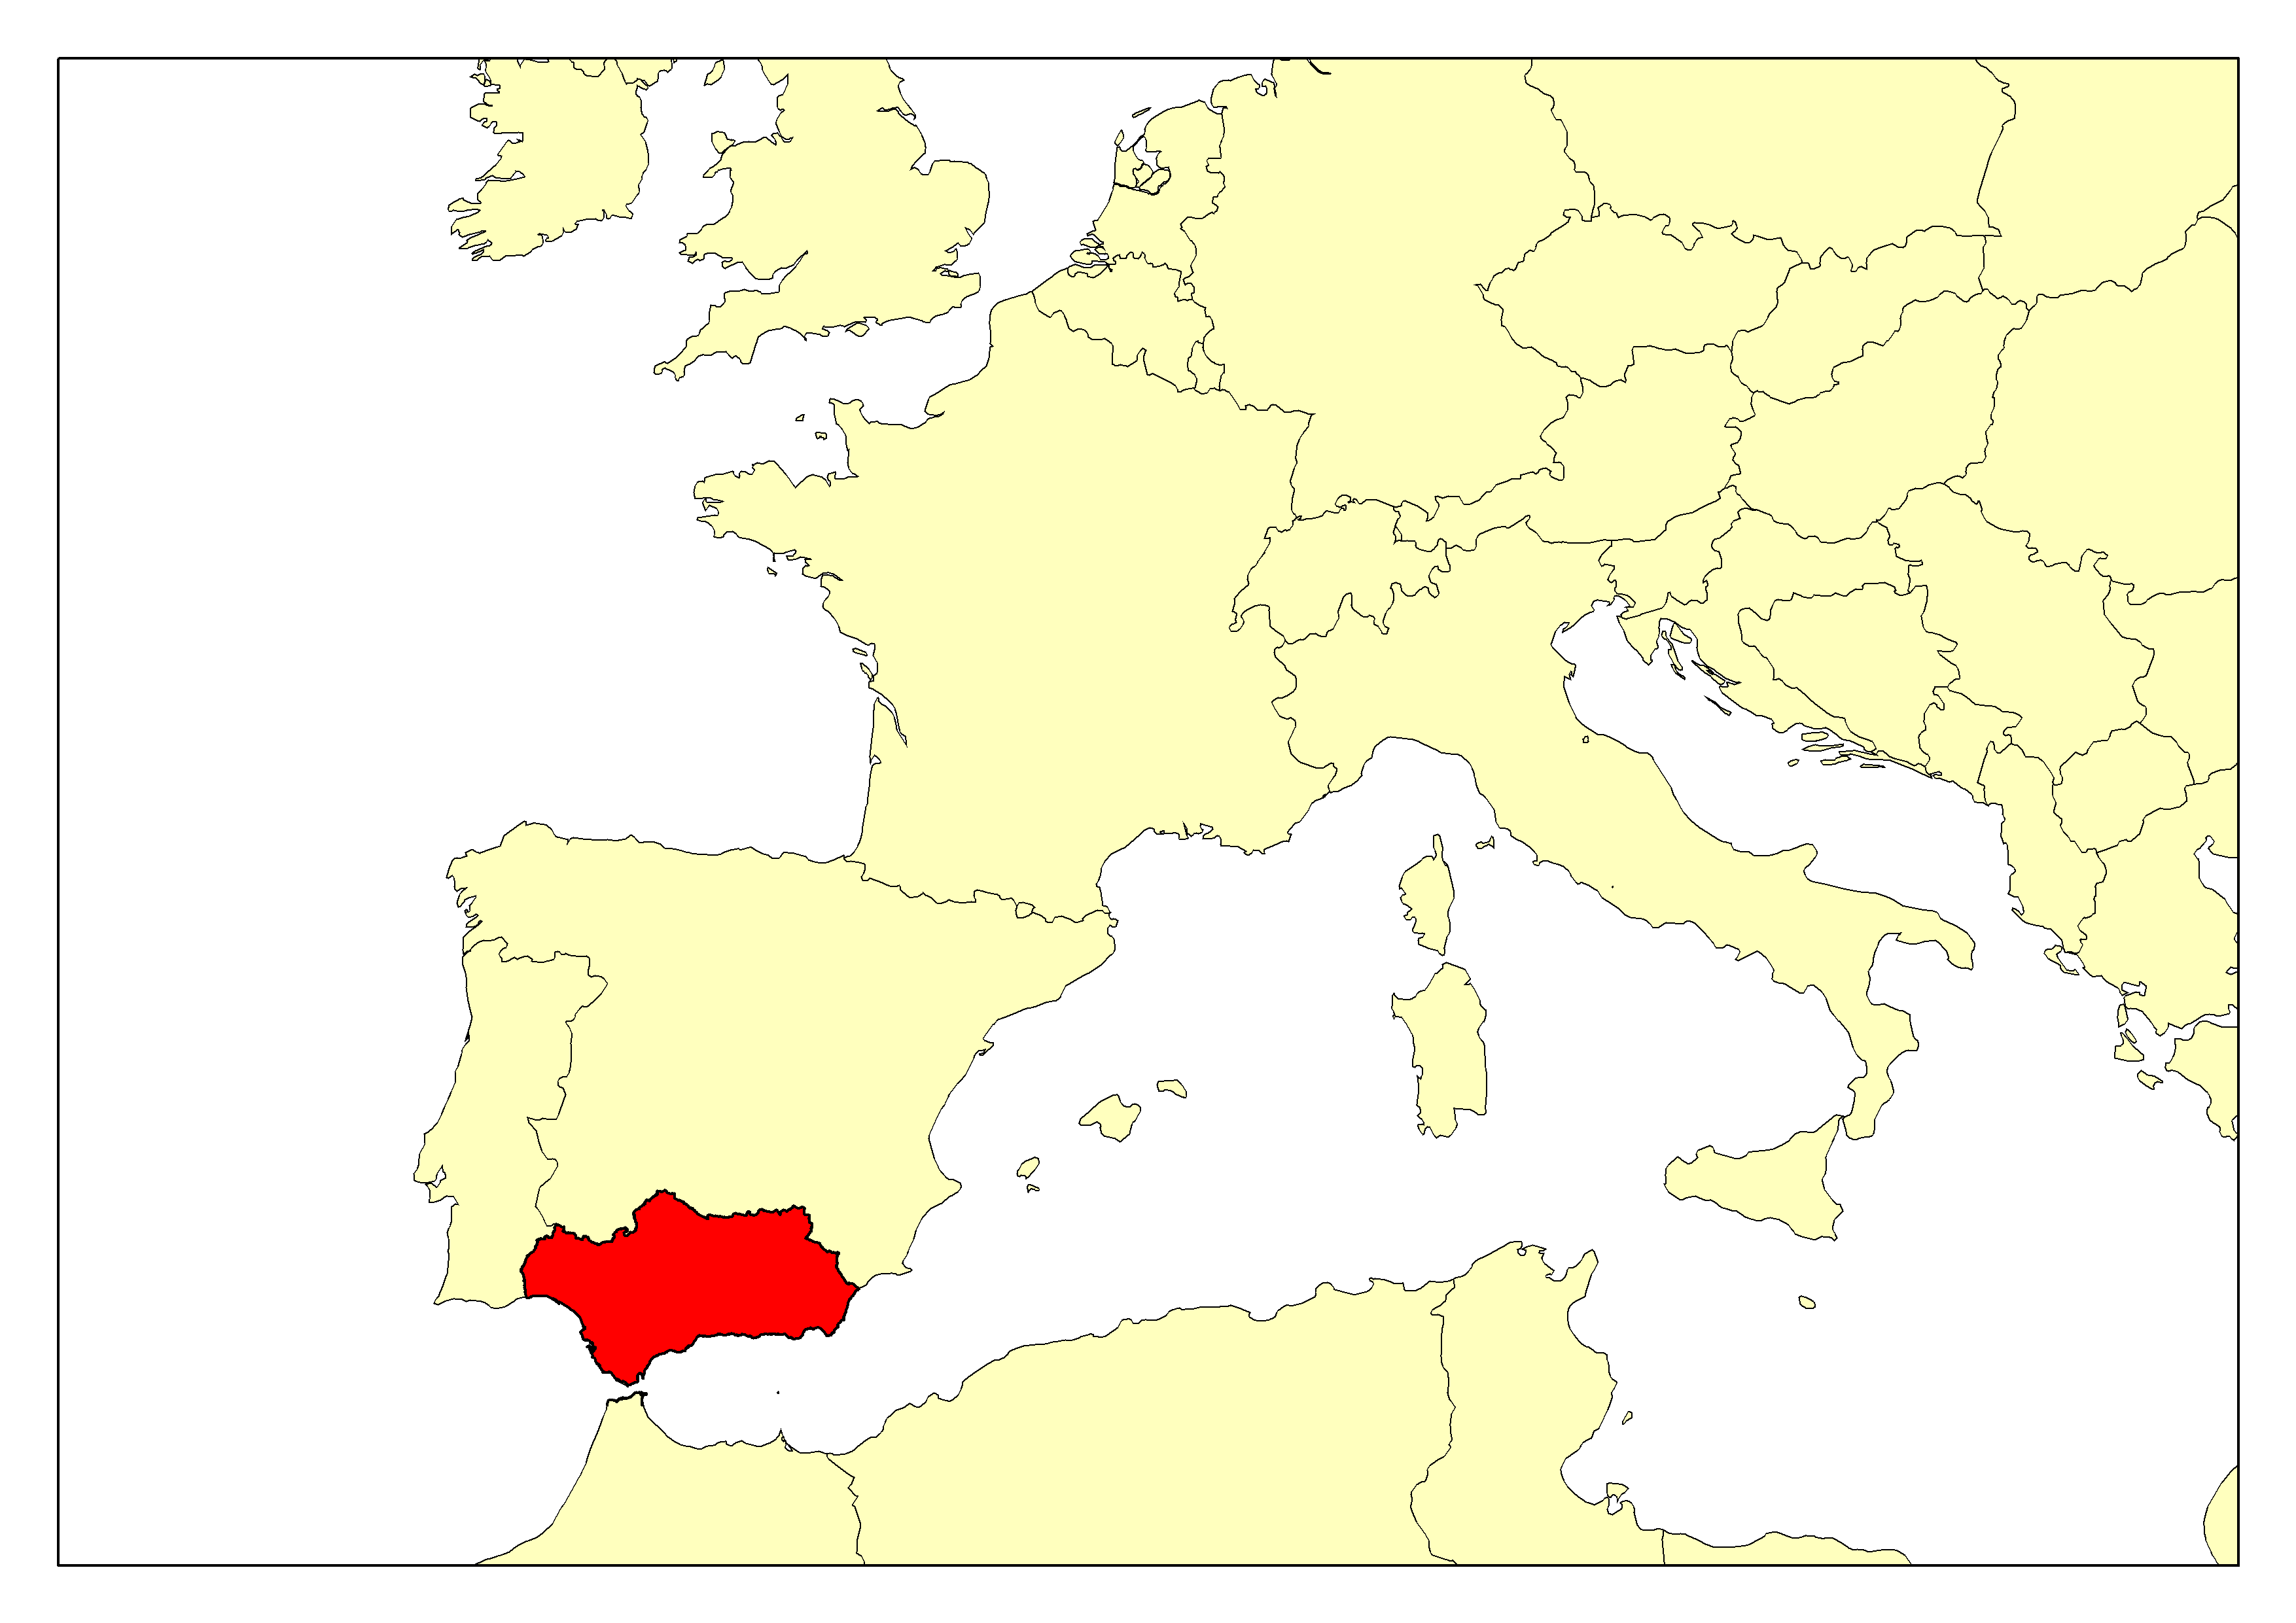
Figure 1: Map of distribution of stations.
CODE | STAGE | RAP ID No. | EUREF  DOMES No. | LOCATION
UCAD | 1 | 1 | 13455M001 | Puerto Real (Cadiz)
HULV | 1 | 2 | 13451M002 | Huelva
ALGC | 1 | 3 | 13456M001 | Algeciras (Cadiz)
SEVI | 1 | 4 | 13457M001 | Seville
MALG | 1 | 5 | 13460M001 | Malaga
GRAN | 1 | 6 | 13459M001 | Granada
ALMR | 1 | 7 | 13437M002 | Almeria
CRDB | 1 | 8 | 13461M001 | Cordoba
UJAE | 1 | 9 | 13458M001 | Jaen
ROND | 2 | 10 | 13464M001 | Ronda (Malaga)
OSUN | 2 | 11 | 13465M001 | Osuna (Seville)
LEBR | 2 | 12 | 13466M001 | Lebrija (Seville)
ARAC | 2 | 13 | 13467M001 | Aracena (Huelva)
POZO | 2 | 14 | 13468M001 | Pozoblanco (Cordoba)
CAAL | 1 | 15 | Not assigned | Calar Alto (Almeria)
ANDU | 2 | 16 | Not assigned | Las Viñas (Jaen)
VIAR | 2 | 17 | Not assigned | Villanueva del Arzobispo (Jaen)
CAST | 2 | 18 | Not assigned | Castril (Granada)
CABR | 2 | 19 | Not assigned | Cabra (Cordoba)
CAZA | 2 | 20 | Not assigned | Cazalla de la Sierra (Seville)
MOTR | 2 | 21 | Not assigned | Motril (Granada)
HUOV | 2 | 22 | Not assigned | Huercal Overa (Almeria)
Table 1: Code, phase, RAP identifying number, EUREF domes number and location of the stations forming the RAP network.

Ten of the stations are located at hospitals belonging to the Andalusian Health Service. This is due to the fact that they are usually the highest buildings in their towns, making it easier to broadcast differential corrections via radio in cities by providing the greatest areas of straight links between the user and the radio station. Furthermore, they enjoy an uninterrupted power supply due to the hospitals’ emergency generators in case of power outages. Each selected hospital belongs to the Andalusian Government’s corporate telecommunications network ensuring a permanent link between the Control Centre and the station via a high-speed internet connection.
The CAAL (Calar Alto) station is located in the Spanish-German Astronomic Centre’s facilities, making the connection of celestial and terrestrial reference frames possible and thus adding value to the network. Therefore, in spite of the fact that this station was initially considered as being part of the second stage, it has become part of the first.
The installation of the geodetic ground markers has been carried out in every location almost in the same way, except in Calar Alto. The monumentation has been built using with a hollow cylindrical steel mast, 10 centimetres in diameter and one and a half centimetres thick which, depending on the location of the station, is fixed by means of two brackets soldered and screwed onto a vertical wall, or onto a 20-centimere square metal base for each side that is screwed onto a pillar of the building. In some cases this cylinder is soldered directly onto the structure of the building (see fig. 2).
In the CAAL station, the monumentation is a geodetic pillar anchored into the ground onto which a two-metre-high steel cylinder was fixed. Three steel cables strung from the mast’s side to the floor ensure its stability in high winds.
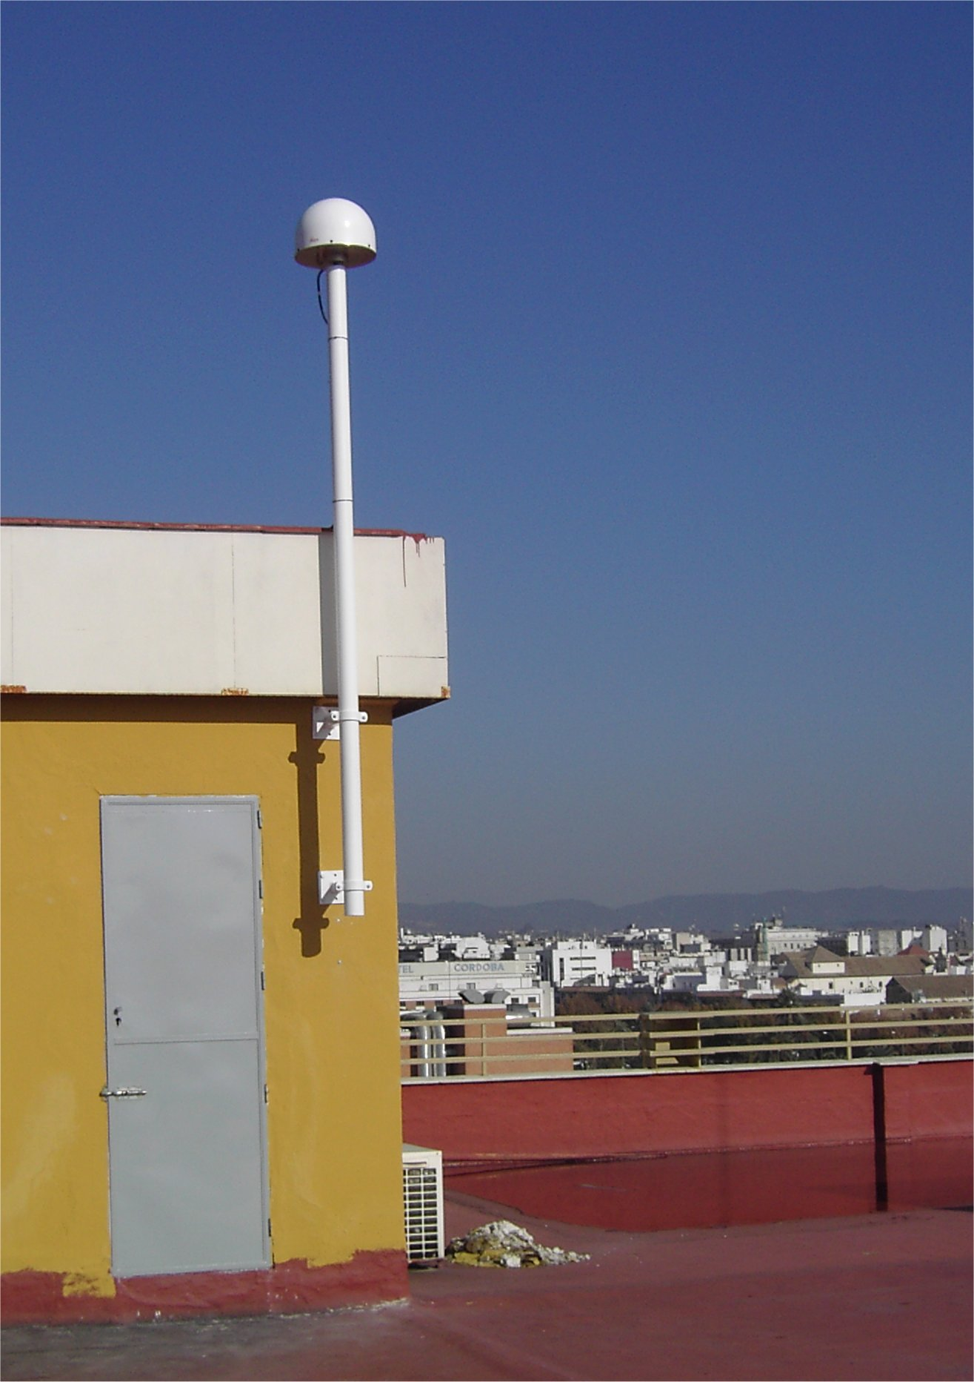
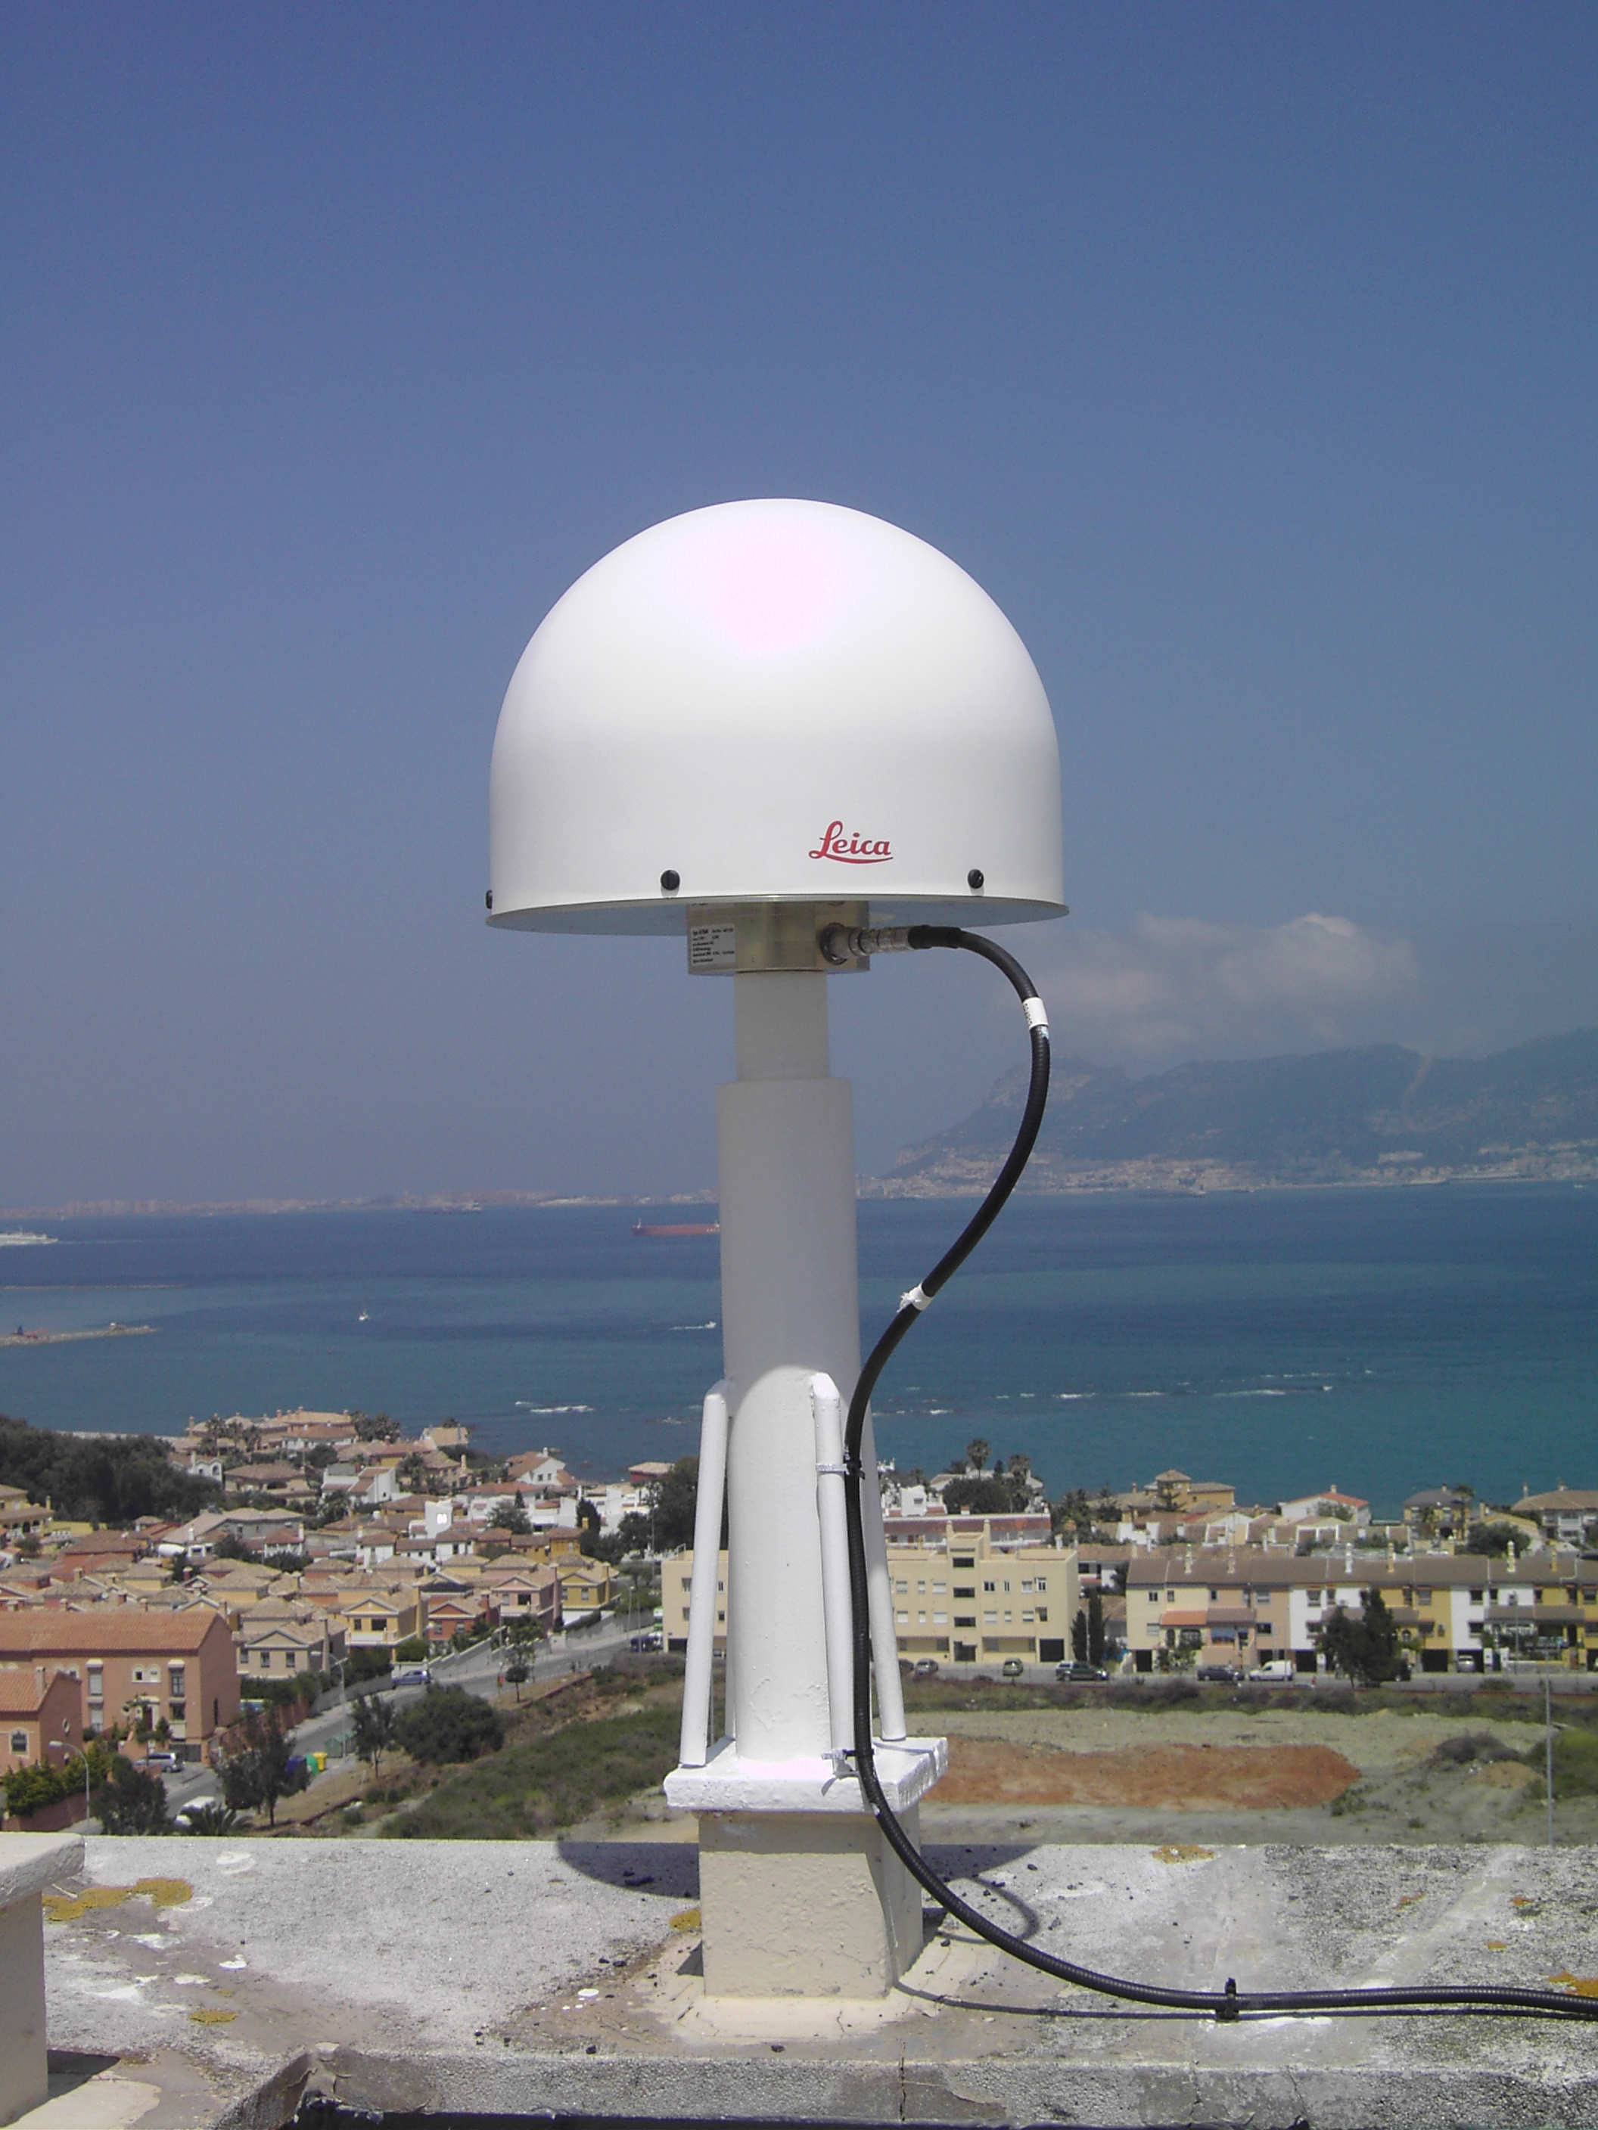
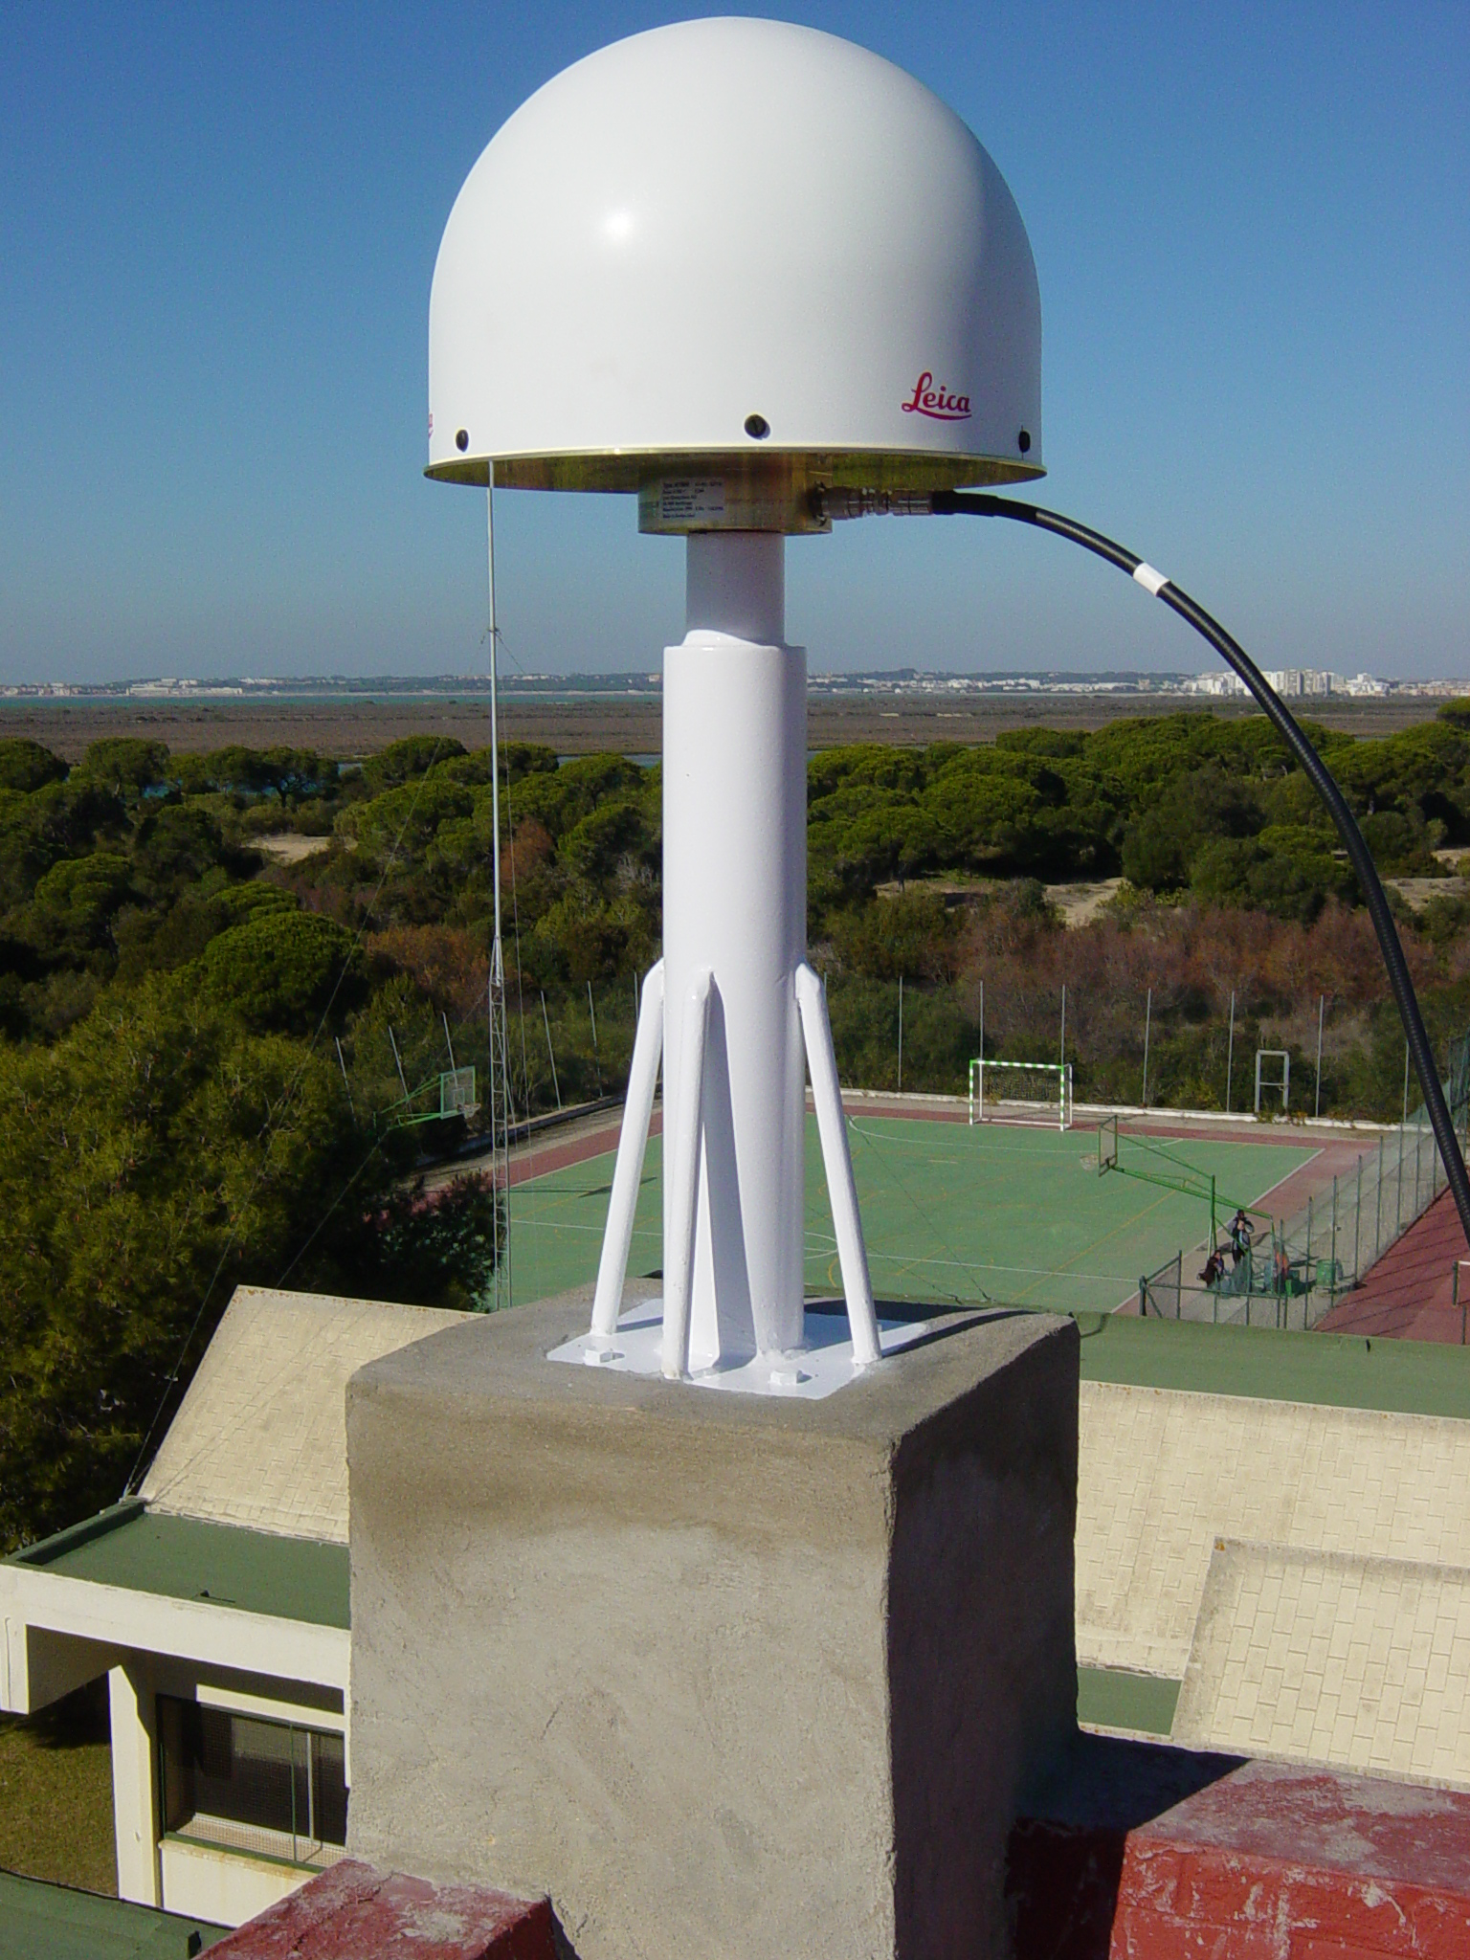

Figure 2: CRDB station, UCAD station, ALGC station.

As mentioned above, depending on the stage to which it belongs, the instrumentation installed at the RAP stations is different.
 | First Stage | Second Stage
Receiver | Double-frequency Leica GRX1200 Pro receivers, with 4 serial ports and an ethernet port with 3 IPs; | Double-frequency Leica GRX1200 Pro receivers, with 4 serial ports and an ethernet port with 3 IPs;
Antenna | Leica AT504 geodetic antenna choke-ring (Dorne-Margolin) with dome | The geodesic antenna is not a choke-ring
Power Supply/internet | Uninterrupted power supply system and permanent internet connection | Uninterrupted power supply system and permanent internet connection
Meteorological station | Paroscientific Met3 meteorological station (pressure, humidity and temperature) | No
Radio Modem | Two radio-modems: PacificCrest and Satelline3AS | No
Table 2: Characteristics of the RAP Stages.

- Checking observed data and station quality
Quality checking in the RAP network is continuous in order to ensure users the very best quality of data provided and is mainly carried out to analyse the stability and time quality of the stations and of the GPS data. The quality of the geodetic network does not merely depend on installed equipment but also on the station’s physical location.
Checking the stations’ quality is performed by analysing different factors related to: the presence of obstacles over the station horizon; reflexion effects of the sign; received signal power and intensity; signal/noise relationship; number of obtained observations and stability of the navigational position.
We are using free QC2SKY (Roggero, 2004) software to evaluate the obstacles that can interfere with the signal reception and the same software is also used to study the multipath effect on each L1 and L2 frequency, representing the obtained data from TEQC software (Translate/Quality Check) of the UNAVCO (University NAVSTAR Consortium). To reduce these effects, a 10º elevation mask is established and geodetic choke-ring antennae are used.
Data quality checking is carried out by comparing the parameters with those obtained by other international GPS networks such as EUREF and IGS and to do so TEQC software is used. We also have some applications programmed for MSDOS and MATLAB that were specifically created by UCA’s Astronomy, Geodesy and Cartography Laboratory to carry out these quality checks.
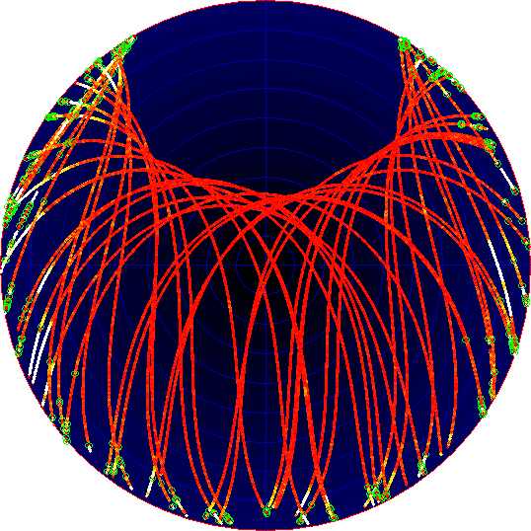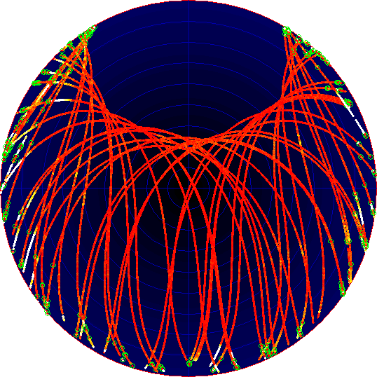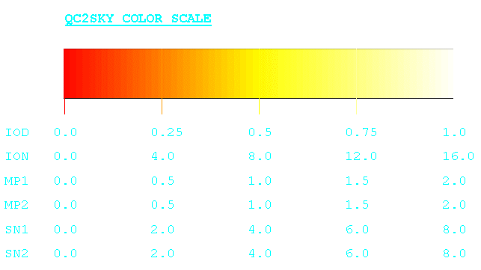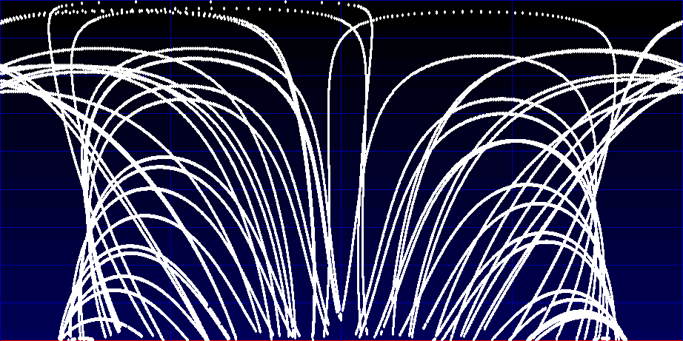
Multipath effect in L1 frequency UCAD station
Multipath effect in L2 frequency UCAD station

0 m. 0.5 m. 1.0 m. 1.5 m. 2.0 m.

90º

0º

N E S W N
Figure 3: Satellite orbits’ projections observed from the UCAD station

The number of observations undertaken is evaluated by contrasting them as contrasted with those expected, according to the criteria established by the International GNSS Service (IGS). Also, the root mean square of the multipath effect, in L1 signal and L2 signal and the number of cycle slips per obtained observations are checked.

- Network calculation and adjustment
Precise positioning and adjustment for the network stations is performed, always taking as a reference stations from permanent networks of the upper order. Bernese 5.0 software is used for this whole process, choosing parameters in accordance with IGS and EUREF standards (Table 3).

Ambiguity Fixing | In the final solution.
Antenna Phase Corrections | IGS Phase Centre Variation files
Cut-off Angle | 10°
Sampling Rate | 180 sec for the final parameter estimation.
Orbits | IGS Final Orbits.
Earth Orientation Parameters | IGS final products
RMS in SINEX files | In the final solution
Ocean Tidal Loading | From Onsala Space Observatory
Mapping Function | Niell Model
Troposphere Parameters | Hourly
Table 3: Parameters established in processing.
The network calculation and adjustment process is performed on a weekly basis. A daily free coordinate is calculated for each station resulting from the relative processing of the defined baselines. They are formed by means of linking a RAP station to the nearest one provided with absolute coordinates with regard to the ITRF2000International Reference Frame. The nearest stations included in the ITRF2000 solutions have been used to provide ITRF coordinates for RAP CGPS stations, SFER (San Fernando-ROA); VILL (Villafranca-NASA); ALAC (Alicante-Spanish IGN) and CASC (Cascais-Portuguese IGN) were added and kept as fixed points in the processing (see Fig. 4).

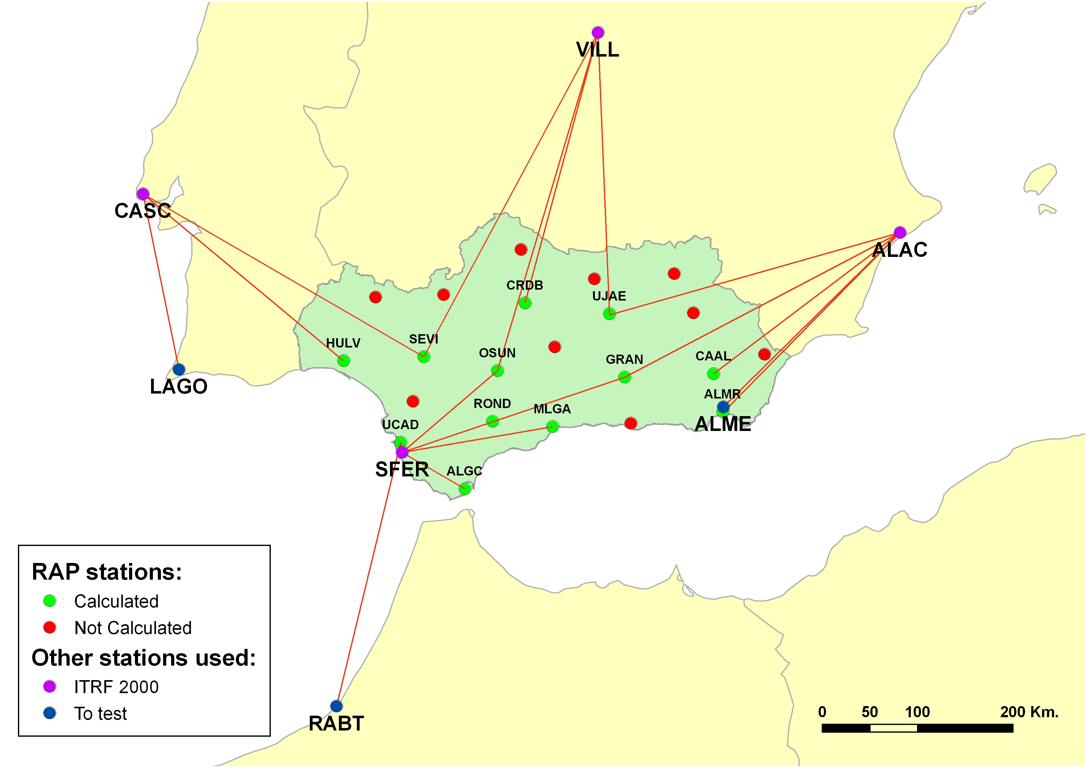

Figure 4: Stations’ location and processed baselines.
Table 4 illustrates the absolute coordinates obtained for the RAP working stations.
COORDINATES REFERRING TO ITRF 2005 (epoch 2007.00)
STATION | ID | X | Y | Z | σx | σy | σz
Algeciras | ALGC | 5135570.488 | -489449.403 | 3738221.994 | 0.004 | 0.003 | 0.005
Almeria | ALMR | 5104673.787 | -217597.585 | 3805329.887 | 0.002 | 0.001 | 0.003
Calar Alto | CAAL | 5081921.346 | -226112.146 | 3838297.860 | 0.003 | 0.001 | 0.003
Cordoba | CRDB | 5023360.485 | -420748.990 | 3894832.326 | 0.001 | 0.003 | 0.003
Granada | GRAN | 5077906.296 | -319058.418 | 3834733.450 | 0.003 | 0.002 | 0.004
Huelva | HULV | 5044358.045 | -611644.019 | 3842260.304 | 0.004 | 0.004 | 0.006
Malaga | MLGA | 5103686.620 | -395880.007 | 3792209.291 | 0.001 | 0.004 | 0.004
Osuna | OSUN | 5064632.443 | -451575.738 | 3838171.986 | 0.003 | 0.004 | 0.006
Ronda | ROND | 5096416.810 | -458741.601 | 3796043.784 | 0.002 | 0.002 | 0.003
Seville | SEVI | 5049343.798 | -528173.267 | 3848027.143 | 0.007 | 0.001 | 0.006
Cadiz | UCAD | 5101056.446 | -555223.428 | 3775752.865 | 0.005 | 0.001 | 0.004
Jaen | UJAE | 5036324.943 | -332898.814 | 3887177.331 | 0.002 | 0.002 | 0.004
Table 4: Coordinates from the first-stage stations and associated errors.
- RAP services.
When fully operational, the RAP network will offer RINEX files with observations performed according to different sampling frequencies to precise relative position and differential corrections via radio or internet to real-time positions with sub-metrical precision.
The access to RINEX data for precise positioning in post-process defines the service known as RAP-FTP. The broadcasting of differential corrections in real-time will be done by means of another two different services named RAP-RTK and RAP-IP.
The RAP-FTP service offers the possibility of downloading, from the RAP WEB page, RINEX files for every station in the network. To do so a PC, internet connection and GPS data processing software, either scientific (e.g. Bernese or GIPSY,) or commercial (e.g. Leica GeoOffice or Trimble Geomatic Office) are required. The files offered to users are of three different types: 24-hour RINEX files with 30-second sampling rates, 1-hour RINEX files with 5-second sampling rates and 24-hour meteorological RINEX files with 5-minute sampling rates (for first stage stations only) .
The RAP-RTK broadcast service that provides the code and phase corrections will be only supported by first stage stations. It requires the users to have radio modems. By using this system more real-time precisions are obtained, with a range of between 10 and 15 kilometres limited by topographical and environmental conditions and requiring a straight line of sight between the user and the antenna.
The RAP-IP service is to broadcast via internet code and phase differential corrections. The best way to use this system is by having a bidirectional connection between the user and the control centre. The transmission scheme is the broadcasting of differential corrections via internet, GPRS or UMTS from a caster (distribution corrections or data centre) installed in the LAGC, to the user. This needs a NTRIP client application and internet access via a WiFi system, a mobile phone line, a CDPD modem, etc., and devices such as a PDA, laptop or mobile phone with a GPRS/UMTS system able to connect to the GPS equipment, if the former is not enabled to do so. The user logs onto the caster and chooses the station from where he or she wants to receive the differential corrections, or by broadcasting his/her approximate location to the caster, this latter deciding which are the best stations for the differential corrections to be broadcasted.
At present, the internet website is being designed. Fig. 5, in Spanish, illustrates a test of the RAP internet website.

5. Future aspects.
A large awareness-raising campaign concerning the Network is under way and there is a great demand for information about it and when it will be available for public use. Furthermore, a series of actions in order to monitor and maintain the network are being considered. Among such actions are the following:
- A review and updating of the equipment and of its auxiliary elements.
- Maintaining the RAP Portal.
- Coordination tasks with other national and international networks.
- Training users in how to use the network.

Moreover, future improvements in the network are being considered, above all in terms of extending the secondary network’s meteorological stations and adding webcams to the stations to provide visual monitoring.
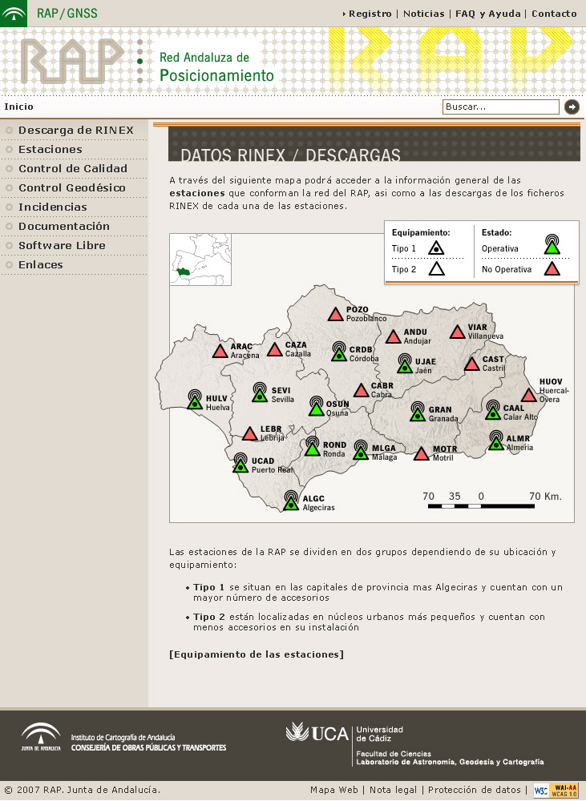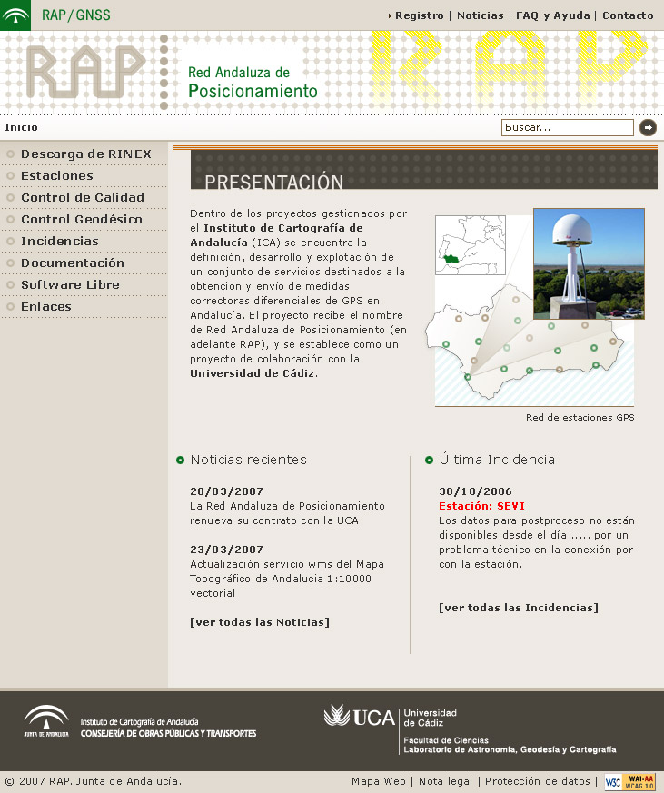
Figure 5: RAP internet website (under construction).

References
- Berrocoso, M., Ramírez, M. E., Perez-Pena, A., Enriquez-Salamanca, J. M., Fernandez, A., Torrecillas, C. (2004). El Sistema de Posicionamiento global. Servicio de Publicaciones de la Universidad de Cadiz.
- Boucher, C. and Altamini, Z. (1996). International Terrestrial Reference Frame. GPS World, V7-N9, ftp://lareg.ensg.ign.fr/pub/itrf/ITRF.TP
- EUREF Permanent Network. http://www.epncb.oma.be
- IGS, International GPS Service. http://igscb.jpl.nasa.gov
- Controllo di qualità delle osservazioni GPS. Il Facoltà di Ingegneria. Politecnico di Torino. Topografía – Ricerca. http://www.vercelli.polito.it/civili/topo0105.htm
- Takacs, B., Bruyninx, C. (2002). Quality Checking the RINEX data of the EUREF Permanent Network. EUREF Publication 10, Eds. J. Torres, H.Hornik, Bundesamt für Kartographie und Geodäsie, Publ. 23, 53-61.

